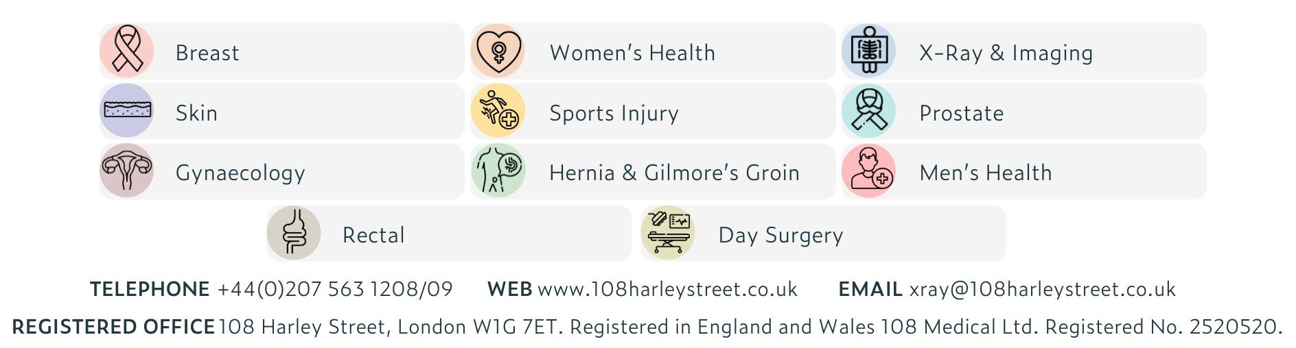

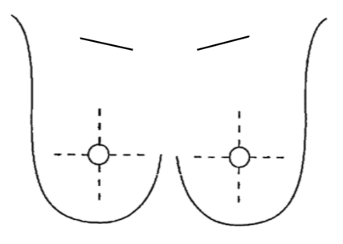
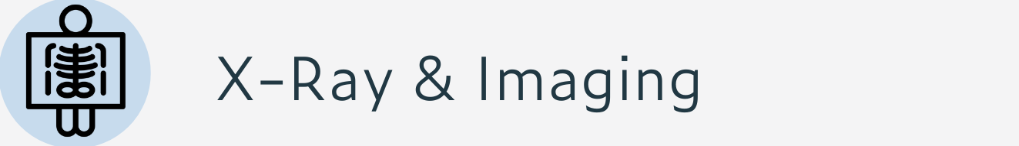

BREAST RADIOLOGY REQUEST FORM
Please ensure previous mammograms available for appointment
Patient Details
Forename: __________________________
Surname: ___________________________
Previous surname: ____________________
Date of Birth: ________________________

Referring Doctor
Name: ____________________________________
Address: __________________________________
_________________________________________
Tel: ______________________________________

Signature: _________________________________
Date: _____________________________________
Justified By: ________________________________
Date: _____________________________________

Examination Required
R L Both
Mammogram
US Breast
US Axilla

Other: ____________________________________
History
Previous Breast Surgery
__________________________________________
Breast Implants Yes No

Date of Last Mammogram: ____________________
Location of Last Mammogram: _________________
__________________________________________
Family History of Cancer:
__________________________________________
Any anticoagulant? Yes No
Does the patient need to stop it for 48 hours prior to exams?
Yes No

Clinical Indication:

Annotate site of symptoms or exam findings

